COVID 19 epidemic trajectory and social distancing modeling results for Ethiopia and Addis Ababa

Collaborators

This work is produced by a team of experts from [EPHI NDMC](https://ephi.gov.et/); FMoH PPMED; AAU, School of Public Health; University of Gondor and a COVID 19 technical working group from the Addis Continental School of Public

Key messages

Currently, about 20 contacts have been identified for each confirmed case, with this

* About one third of the population would be infected at the peak
* The outbreak will have protracted trajectory, where the infection peaks two months from now

Reducing contacts by 50% through enforcing social distancing

* Averts 15 and 0.87 million infections that would have occurred at the peak at the national level and in Addis Ababa respectively.

To shape the outbreak trajectory; to reduce infection and case fatalities early capturing of community transmission is crucial through:

* Increasing testing and contact tracing, considering mobile tracking
* Enhance case detection through revision of case definition, diagnostic criteria and surveillance approaches
* Cascading screening and diagnosis to health facilities to early capture symptomatic cases as Sever Acute Respiratory Infection (SARI)

Distribution of laboratory confirmed cases and contacts across Ethiopia

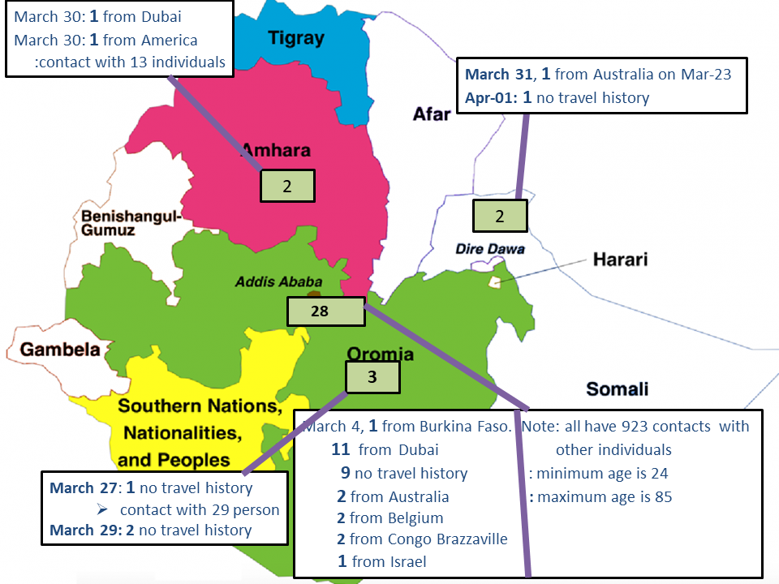

COVID 19 outbreak trajectory in Ethiopia

At the peak of the outbreak about 60% of the population would be exposed to the virus. By the end of May 1.94 million people would be infected with the virus. The outbreak will reach to peak on day 110 infecting likely 33, 697,791 people. 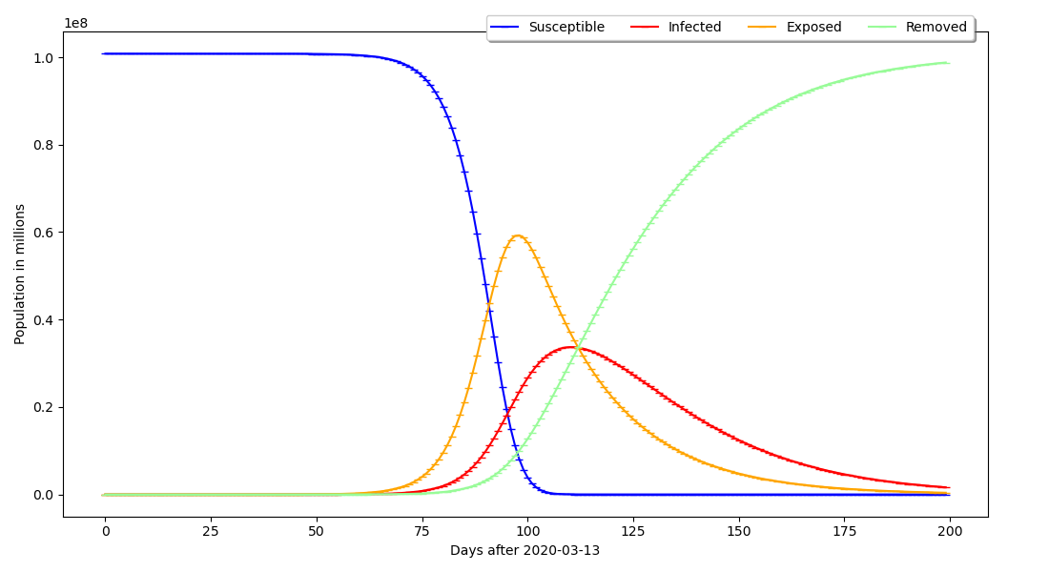  
NB: days on the x-axis starting from the date the first case was reported

Effect of social distancing on the outbreak trajectory at the National Level

Social distancing reduces the number of contacts an infected person would have. 50% reduction in contacts could avert 15,442,351 of the infections that could have occurred at the peak 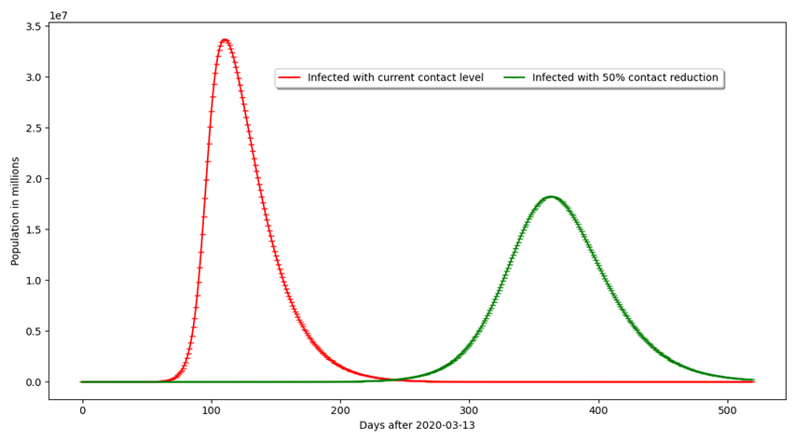  
NB: days on the x-axis starting from the date the first case was reported

Outbreak trajectory in Addis Ababa

At the peak of the outbreak, > 50% of the population would be exposed to the virus. By the end of April about 235,000 people would be infected. The outbreak will reach to peak on day 67 likely infecting 1,484,238 people. 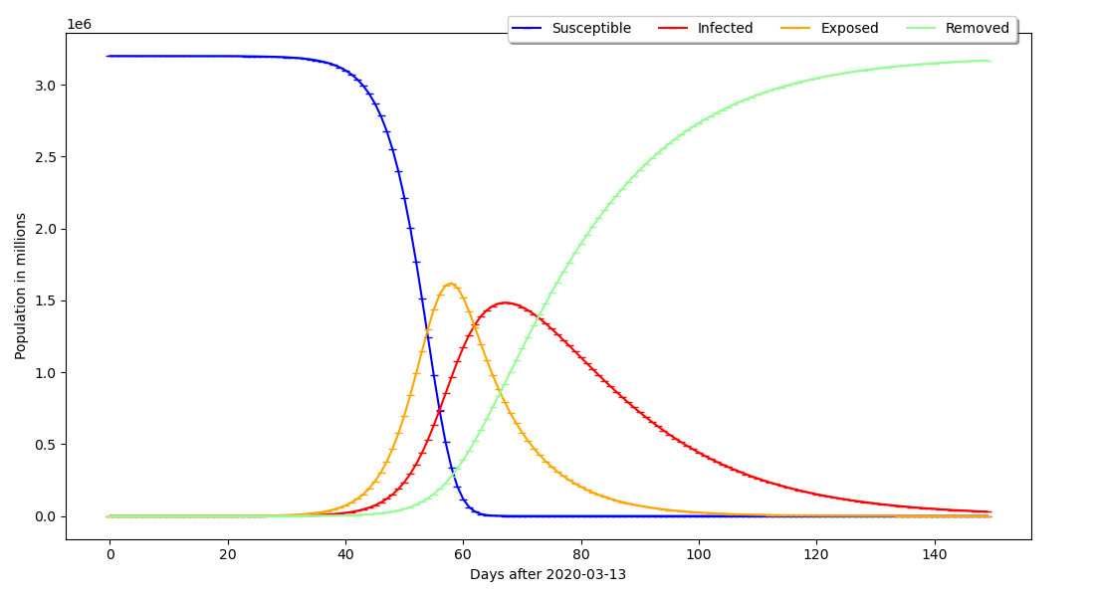  
NB: days on the x-axis starting from the date the first case was reported

Effect of social distancing in Addis Ababa

50% reduction in contacts could avert 872,243 of the infections that could have occurred at the peak. 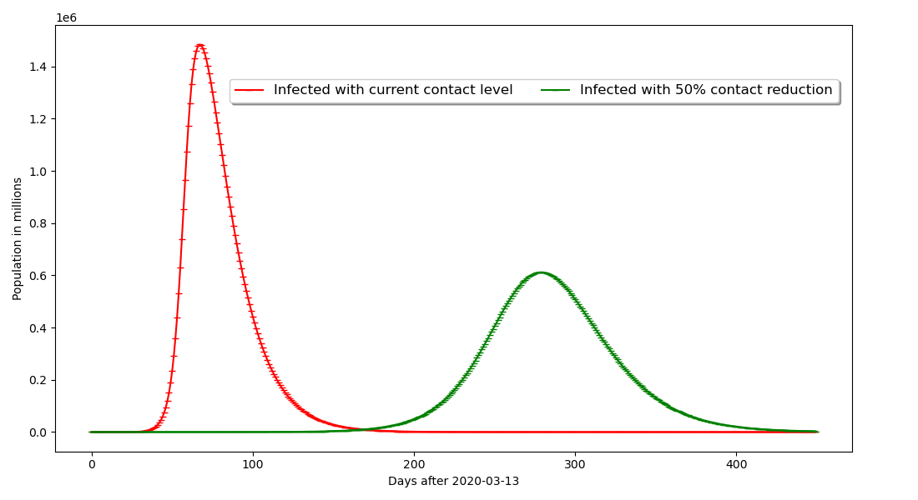  
NB: days on the x-axis starting from the date the first case was reported

Recommendations

In order to avoid the outcome of this scenarios:

* The governments need to enforce social distancing
* The public should obey the restriction posed by the government for their own sake
* Expand testing for early diagnosis of cases and to contain community transmission

Phone Number: +251-112305079

Email: [ndmc.evidence@gmail.com](http://localhost/covid19/ndmc-covid19/blank.php)

**[Second Evidence Briefing by NDMC - 05, April 2020](http://localhost/covid19/ndmc-covid19/blank.php" \l "collapseCardExample1)**

[Download this briefing](http://localhost/covid19/ndmc-covid19/blank.php)

Current Policy Options/Interventions to respond to COVID-19 Pandemic

Executive Summary

On 5th April, 2020, the Novel Coronavirus 2019 (COVID-19) has already affected 208 countries and territories around the world and 2 international conveyances since December 2019. It has already infected 1,225,047 people globally and 43 persons in Ethiopia since December 2019, and killed 66, 503 people globally and 2 persons in Ethiopia during the same period. Currently, COVID-19 has no specific antiviral agent for the treatment of the infection and there is no vaccine to prevent. As a result, implementation of public health prevention and control measures that aim slowing down and stopping of transmission is crucial. Detecting and testing suspected cases and tracking contacts with suspected and/or confirmed cases, individual social distancing that focuses on isolation of case, quarantine of contacts, and stay-at home; social distancing affecting multiple persons such as closure of educational institutions and workplaces, measures for special populations, mass gathering cancellations, and mandatory quarantine of a building or residential area; and environmental disinfection and use of personal protective equipment are currently available policy options to fight the disease. Considerations of local context in response to COVID-19 measures are crucial for slowing down and controlling the pandemic in order to minimize the negative social and economic consequences of the prevention and control measures.

Key Findings

* Implementation of public health control measures that aim prevention of transmission is crucial to combat the COVID-19 pandemic
* A combination of interventions, especially non- pharmaceutical interventions, should be in place to contain the spread of the COVID-19 which may be most effective
* Considerations of local context in response to COVID-19 measures are crucial for slowing down and controlling the pandemic

Background

By April 05, 2020, according to World Population, the coronavirus COVID-19 is affecting 208 countries and territories around the world and 2 international conveyances. The disease has already infected 1,225,047 people globally since December 2019. In Ethiopia, the virus has already infected 43 individuals from March 12 to April 05, 2020.  
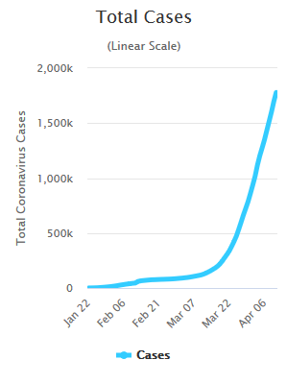  
**Global cases:** Source: Worldometer, COVID-19. Last updated: April 05, 2020, 14:14 GMT  
  
In the same period the disease has already claimed the life of 66,503 people and 2 persons in Ethiopia.  
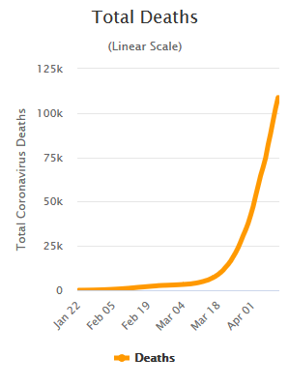  
**Global deaths:** Source: Worldometer, COVID-19 Pandemic. Last updated: April 05, 2020,14:14 GMT  
  
Currently, COVID-19 has no specific antiviral agent for the treatment of the infection and there is no vaccine to prevent. As a result, implementation of public health control measures that aims prevention of transmission is crucial.

Policy Options

Pharmaceutical solutions, including vaccines and treatments for COVID-19, have been reported to take 12-18 months to develop. The immediate solution for slowing down the COVID-19 pandemic and minimize the social and economic catastrophe of the disease is to focus on prevention and control mechanisms. Evidence show shat a variety of non- pharmaceutical interventions have been implemented to curve the diseases. The policy options that have been implemented include: detection and testing, social distancing affecting individual and multiple persons, environmental disinfection and use of personal protective equipment.

1. Detecting and Testing

Identification suspected cases and follow-up of contacts is crucial. Testing could be done for both suspected cases or the whole However, in a situation like this, the better option is to test the suspect cases. Testing everybody will not be feasible for countries with limited resources and may give a false sense of security if the test result is negative.

2. Individual Social Distancing

2.1 Isolation of cases:

This is for confirmed or suspected cases of COVID19. They are either hospitalized (usually for moderate or severe cases) to provide care, or managed in dedicated isolation facilities or at home (mild cases).

2.2 Quarantine of contacts:

This is for healthy person(s) who have had a high- or low-risk contact with a confirmed COVID-19 case. Quarantine of cases can be voluntary or mandatory. Resistance and non-compliance will be greater if impacts of this policy are inequitable, and for those on low incomes, loss of income means inability to pay for necessities.

2.3 Stay-at-home:

This a comprehensive recommendation for the public to stay at home and avoid mass gatherings and close contacts with people, especially known high-risk groups. Concerns are likely to arise about impact on others within the household.

3. Social Distancing affecting multiple persons

3.1 Closure of educational institutions:

It refers to closure of schools (including day care centres, kindergartens, primary and secondary schools), and higher educational institutions (including universities, research institutes, etc.).

3.2 Workplace closure:

Closure of offices, factories, retail outlets, agricultural production, construction, restaurants, cafes/bars, sports clubs,haulage/transport etc. It can be flexible working schedules/shifts for employees; opportunities for distance working/teleworking; encouraging physical distancing measures within the workspace; increased use of email and teleconferences to reduce close contacts; reduced contact between employees and customers; reduced contact between employees; adoption of flexible leave policies; and promoting the use of other personal protective and environmental countermeasures.

3.3 Measure for special populations:

It refers to measures to limit outside visitors and limit the contact between the inmates/patients in confined settings, such as long-term care facilities, either for the elderly or persons with special needs; psychiatric institutions; homeless shelters; and prisons.

3.4 Mass gathering cancellations:

It means the cancelations of cultural, sporting, festival, and faith- based events; conferences, meetings, trade fairs, etc.

3.5 Mandatory quarantine of a building or residential area(s):

Refers to the quarantine and closing off of a building or whole residential area (city, region...)

3.6 Environmental disinfection and use of personal protective equipment:

Environmental disinfection can and use of personal protective equipment can limit the spread of the virus from the environment- to-human, and human-to human, respectively.

How to implementing prevention and control measures

Measures which are acceptable and feasible in one country/setting may not be in other countries. It is important to consider, anticipate and plan for mitigation, while keeping in mind the considerable public reaction that public health measures such as social distancing. There is no one-size-fits-all approach for implementation of prevention and control measures of COVID-19. While implementing social distancing, it is important to assess its socio-economic consequences at country and individual level. Frustration may arise in those unable to reduce social contact in their work. Guidance will be needed to mitigate this. Therefore countries implementing a single intervention or combination of interventions need to consider the following:

* Rights of individuals and groups
* Proportionality of the response
* Risk communication
* Countering stigma
* Support for people and communities, especially for vulnerable groups
* Promoting solidarity and mutual community support
* Financial compensation for lost income and employment
* Ensuring business continuity
* Process and impact evaluation

Recommendations

* Use a combination of interventions and consider the feasibility of the intervention based on the country’s context, and monitor progress.
* Consider closed educational institutions to be potential sites for managing the pandemic.
* Implement measures to monitor shut down places of social gathering, including restaurants, bars, movie theaters, concerts, sporting events, clubs, game centers, etc.
* Seal or restrict all Ethiopian borders to all forms of traffic/transport, and do not unseal borders until the pandemic is under control.
* Continue quarantining returning citizens returning from other countries in hotels or other facilities, and ensure these facilities are supplied with food, water, sanitary materials, communication capabilities, and other basic needs.
* Aware the people not to leave their home for anything other than medically necessary movement or work in support of the COVID-19 measures.
* Begin to gradually lift the measures if the observed reproduction number drops sufficiently. We must be extremely vigilant and thorough with our testing in order not to stop social distancing actions and promotion of personal hygiene too early.
* Aggressively quarantine families of new patients for two to three weeks while provide supports for those families during the quarantine period.
* In the preparation, take into account the reappearance of the disease and watch case counts for signals of reappearance.
* Ensure a widespread surveillance and testing capability to detect and monitor infections.

Phone Number: +251-112305079

Email: [ndmc.evidence@gmail.com](http://localhost/covid19/ndmc-covid19/blank.php)